**OVERALL ANALYSIS OF ADIDAS COMPANY**

**Name: Pallavi Dumpa**

**Batch: Data Analytics-2**

**Define Objectives:**

The goal of this project is to convert the raw collected data into action and meaningful insights. The key business questions driving in this project include:

* To know the sales and trend analysis using sales data from the adidas dataset.
* To know the product and trend analysis using sales data from the adidas dataset
* To know financial analysis using the sales data from the adidas dataset.
* To know YoY, MoM- sales, profit, units sold and the transactions done, so that to know the how the business is running
* To find profit and sales of the current year from the beginning of the year to till date.
* To know sales performance across different region, states, cities and time periods.
* To know Sales VS Profit, Operating Profit, Operating Margin for knowing financial status of the company.
* To know how many units are sold and operating profit by product.

**Set Goals:**

**The expected outcomes from this project are:**

* Visualize sales performance across multiple dimension (region, product, retailer, time, etc)
* Visualize product performance across multiple dimension (sales, units sold, profit, etc)
* Visualize financial performance across multiple dimension ( profit and operating margin)
* Identify top and bottom states in which the most sales had happened.
* Highlight sales, product, financial trends to support strategic planning and inventory management.
* Retailers to understand and predict purchasing behavior.
* Create predictive insights for future sales, product and financial status using time series forecasting.
* Enable data driven decisions for sales strategy, product strategy, financial strategy, resource allocation and marketing efforts.

**Data Collection:**

To perform overall analysis. I gathered relevant dataset from the **Kaggle**. The dataset limited to around 9500rows and 13 columns. Each row contains detailed information such as Retailer, Retailer ID, Invoice date, Region, State, Products, Price per unit, Units sold, Total sales, Operating profit, Operating margin, Sales method.

**Data Preparation:**

After downloading the dataset from the Kaggle. The data is in csv file so I converted it and opened it in excel. I created the table for the data and I created a worksheet and named as 2020, in which it contains data related to year 2020 transactions only. I the same way I created another worksheet, in which it contains data related to year 2021. And 3rd worksheet is calendar, it contains the columns with the following the attributes like date, year, month, month number, weekday name and weekday number. So, this is how I prepared the data for further analysis using Power BI

**Import Data to Power BI:**

**Unload Excel File**

**Step 1**: Open Power BI

First, I opened Power BI desktop on my laptop.

Step 2: Used Get Data option

On the Home Tab, I clicked on ‘Get Data’ and selected Excel from the options.

Step 3: Choose My Excel File

I browsed through my files and selected the Excel file which I had prepared earlier, then clicked open.

Step 4: Selected the sheets I needed

A Navigator window popped up showing the sheets and tables available, so I selected the main data sheet.

Step 5: Loaded the data

Since my data is not cleaned, I clicked on Transform Data, to perform cleaning process in Power Query Editor.

**Data Cleaning:**

* Applied Proper, Trim, and clean formats to standardize text present in the data.
* Handling missing and inconsistent data.
* Removed duplicate records to ensure data accuracy.
* Changed the date format from the long date format to short date format
* **Cleaned and clicked on apply and close so that the cleaned data is transformed to the Power BI for creation further analyzing and visualization purpose.**

**Build Data Model:**

In my data model, the **Main data** serves as the **fact table** in which it contains all the **foreign keys**.

The **calendar, 2020, 2021 table** serves as the **dimensional table** in which it contains all the **primary keys**.

The model follows the star scheme structure, where fact table in the center and connected tables to dimensional table through one-to-many relationship and many-many-relationship.

* The main data table having relationship with calendar table with many-to-one cardinality because each record in main data table can relate to multiple records in calendar table, but each record (**that is date**) in calendar table relates to only one record (**that is invoice date**) in the main data table.
* The **main data** table having relationship with **2020 year table and 2021** year table with **many-to-many cardinality** because many **attributes in the main data table are related with many attributes in the 2020 and 2021 year tables.**

**Structure of Star Schema:**

Star Schema is a type of data model used in data warehousing to support business intelligent that organize the data into:

* One central fact table (with the measurable attributes)
* Multiple dimensional tables (with descriptive attributes)

The structure looks like star, where fact table in the center and dimension tables surround it like points of star.

* I used star scheme to design the data model. This helped in creating efficient relationship and improving performance in Power BI.

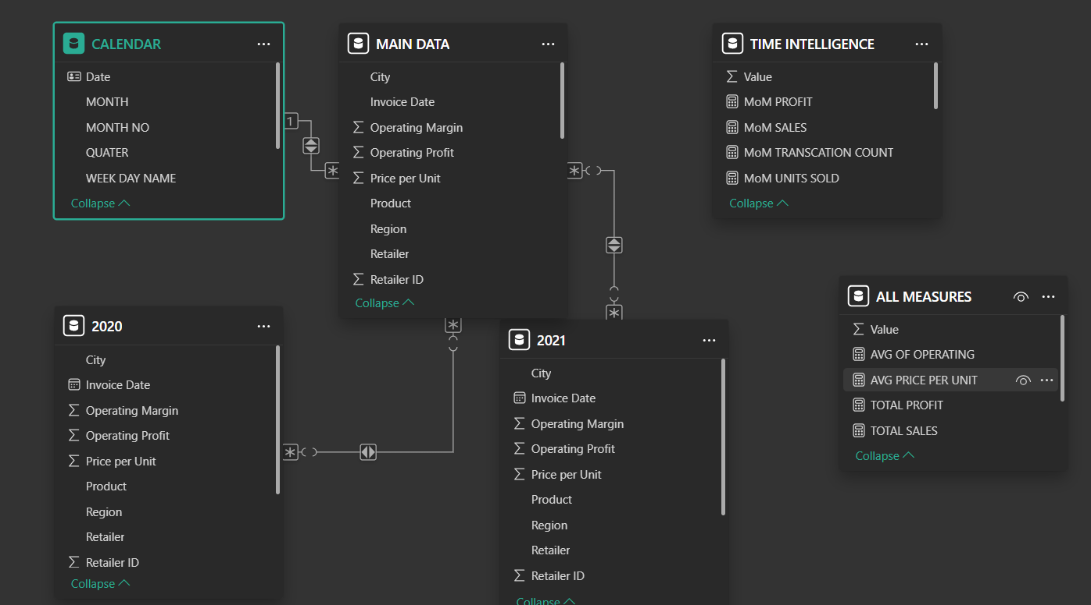

**Data Analysis:**

After loaded the data to Power BI, the records in the calendar table are blank so because of this reason I created the New Table in the Power bi and named the Table as the Calendar.

I used following DAX Expressions creating Calendar Table are as follows:

Calendar(name of the table)= ADDCOLUMNS{helps to add columns in the table} CALENDARAUTO(), {automatically generates a date table based on the date values present in data model. It was created which is essential for time-based analysis and reporting}

In the calendar table I used the following DAX Expressions:

CALENDER = ADDCOLUMNS(CALENDARAUTO(),

"YEAR", YEAR([Date]),

"MONTH NO", MONTH([Date]),

"MONTH", FORMAT([Date], "MMM"),

"WEEK DAY NO", WEEKDAY([Date],2),

"WEEK DAY NAME", FORMAT([Date], "DDDD"),

"QUATER", FORMAT([Date], "Q"))

**I marked the calendar table as data table**.

* I created another table and named **as All Measures** and in the I created all the scalar measures used for analysing the data.

TOTAL SALES = SUM('MAIN DATA'[Total Sales])

TOTAL PROFIT = SUM('MAIN DATA'[Operating Profit])

TOTAL TRANSACTIONS = COUNTROWS('MAIN DATA')

TOTAL UNITS SOLD = SUM('MAIN DATA'[Units Sold])

* I created another table and named as **Time Intelligence** and in the I created all the scalar measures used for knowing the financial growth of the business

YOY SALES=

VAR PY=

CALCUALTE ([TOTAL SALES], DATEADD (CALENDAR[DATE],

-1, YEAR)),

VAR CY= [TOTAL SALES],

RETURN

IF (AND (PY,CY), CY/PY-1)

YOY PROFIT=

VAR PY=

CALCUALTE ([TOTAL PROFIT], DATEADD (CALENDAR[DATE],

-1, YEAR)),

VAR CY= [TOTAL PROFIT],

RETURN

IF (AND (PY,CY), CY/PY-1)

In the same way I created MoM sales, MoM profit, QoQ sales and profit, so over there we have select Month and Quater instead of Year, from this DAX EXPRESSIONS we can know the growth rate of the business.

I also used other Dax expressions like YTD sales and profit to know sales and profits of till date.

**Using Visualization for creating meaning Insights:**

**From sales and trend analysis dashboard:**

* + **In store** sales are more.
  + **West Gear** sales are more.
  + Sales are more in the month of **July.**
  + Sales are more in West **Region**.
  + Sales are more in the **New York State**.

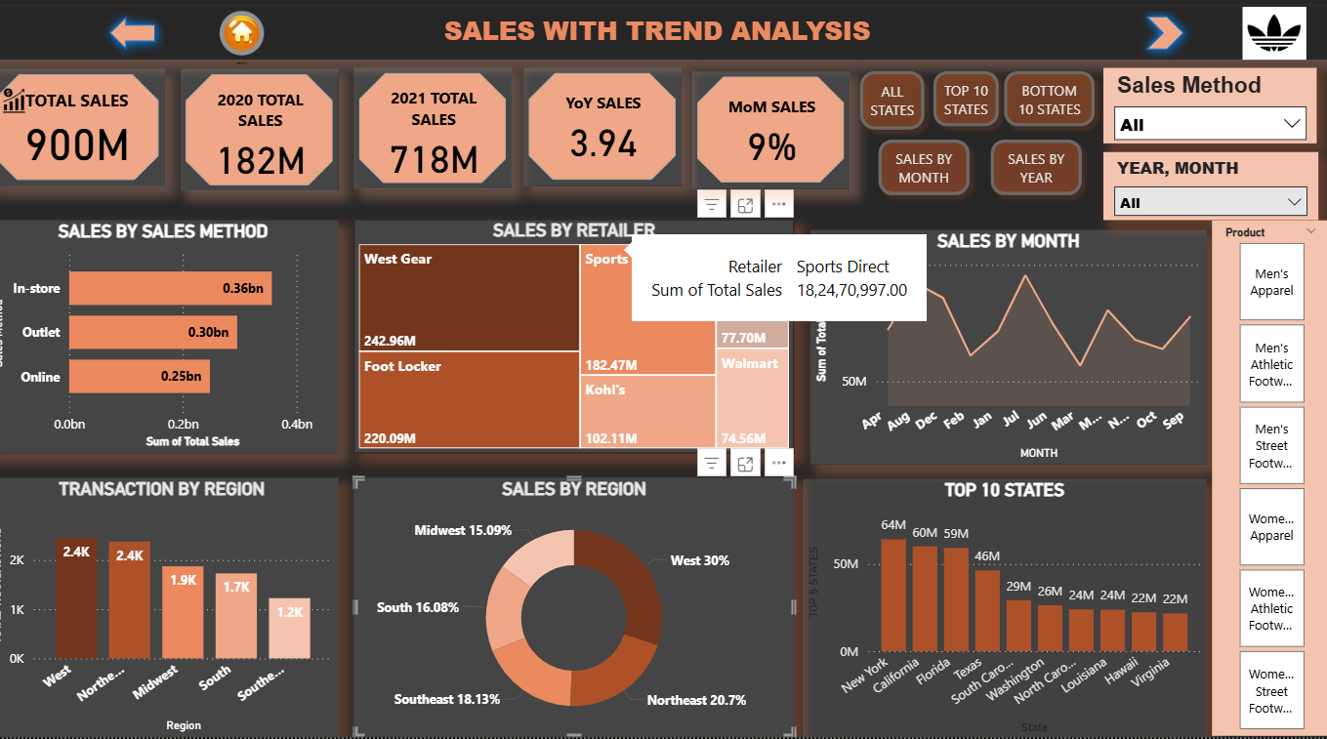

**From Product and trend analysis dashboard:**

* **Men’s street Footwear** sales, units sold and profit is more when compared with other products.
* More Number of units are sold in the month of **August.**

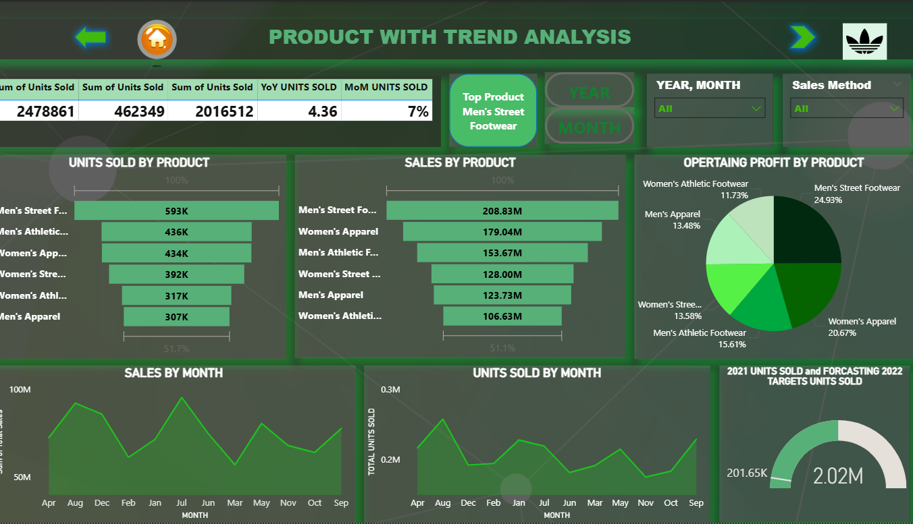

**From Financial and trend analysis dashboard:**

* Profit is more in the month of **July**.
* Operating Margin is more in the month of **September**.
* YoY sales growth is 3.94.
* YoY profit growth is 4.24.

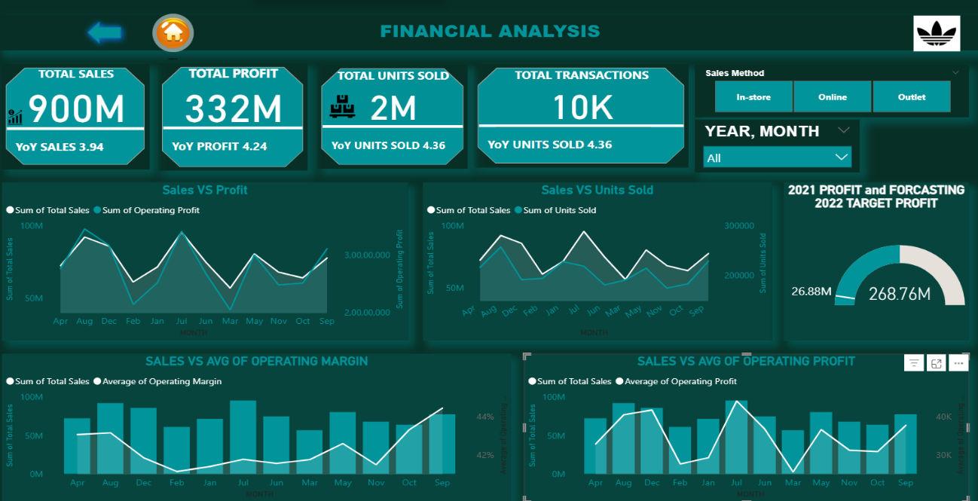

* Finally I conclude, by increasing discounts in online platforms we can we increase more sales using online platforms like Amazon etc.
* We can increase sales in other Regions by providing seasonal or festival offers.
* We can increase sales of other Products by providing 1+1 offer at-times so that the customers may attract and buy other products which are having 1+1 offer (Products which include 1+1 offer are Men’s Apparels, Women’s Athletic Foot ware, Women’s Street Foot ware etc.

Thank You.